

Foundations of Programming
Assignment No. : 13

PROBLEM STATEMENT:
Write a program in C to accept a number from the user and print the digits of the number in reverse order.

OBJECTIVE:
• To understand number manipulation using loops
. • To learn the use of modulo (%) and division (/) operators.
• To implement logic for reversing digits of a number.
• To improve problem-solving skills using iterative structures.

THEORY:
• To understand number manipulation using loops. • To learn the use of modulo (%) and division (/) operators. • To implement logic for reversing digits of a number. • To improve problem-solving skills using iterative structures.

PLATFORM:
Linux

ALGORITHM:
1 START
2 Declare integer variables: num, remainder.
3 Read the input number from the user and store it in num.
4 Check if the number is $0$:
- If num == 0, print 0 and go to Step 8.
5 Handle Negative Numbers (Optional but recommended):
- If num < 0, print a minus sign and multiply num by $-1$.
6 Loop while num is greater than $0$:
- a. Calculate remainder = num % 10 (This extracts the last digit).
- b. Print the remainder.
- c. Update num = num / 10 (This removes the last digit by performing integer division).
7 End Loop

8 STOP

C PROGRAM:

INPUT:
INPUT:
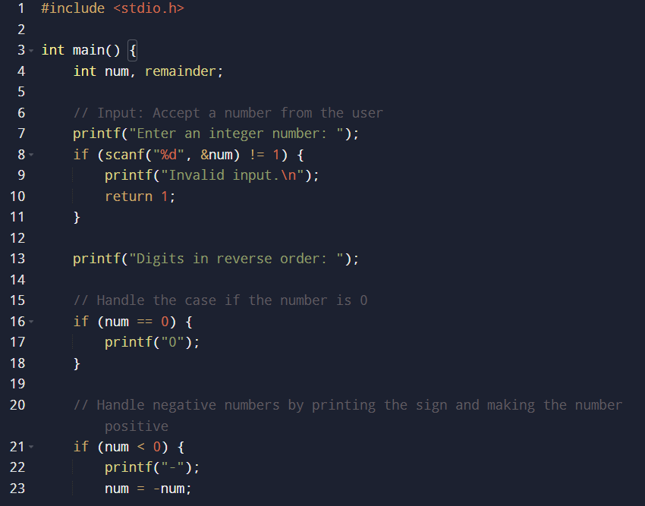
The user enters an integer number.

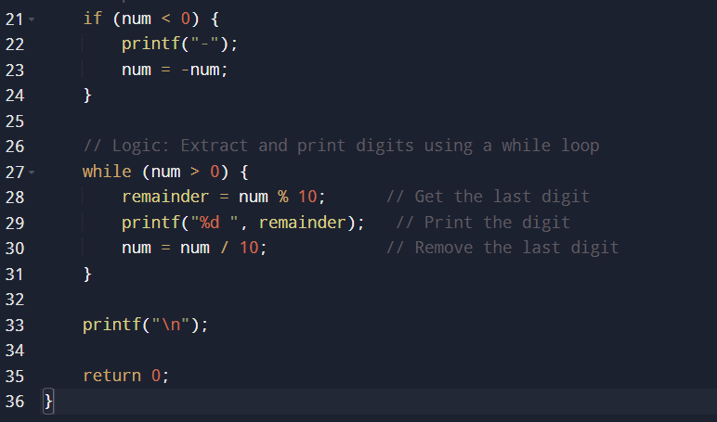

OUTPUT:
The program prints the digits of the number in reverse order.
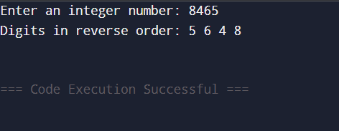

CONCLUSION:
Thus, the program to print the digits of a number in reverse order was successfully implemented using C programming. The program demonstrates the effective use of loops, modulo operator, and division operator.

FAQs:
- Why is the modulo operator (%) used in this program?
- Why is division by 10 used after extracting each digit?
- What happens if the input number is zero?
- How will the program behave for negative numbers?
- Why is a while loop preferred for this operation?

